# **Assignment 3 (MSIS2503-40134,40153,40170)**

Q1) **Create a table book_store with columns Book_id VARCHAR(255) NOT NULL, Book_Name VARCHAR(255) NOT NULL, Book_genre VARCHAR(255) NOT NULL, Status VARCHAR(255) NOT NULL, PRIMARY KEY (Book_id).**

* **Screenshot of MYSQL query and results as shown below:**

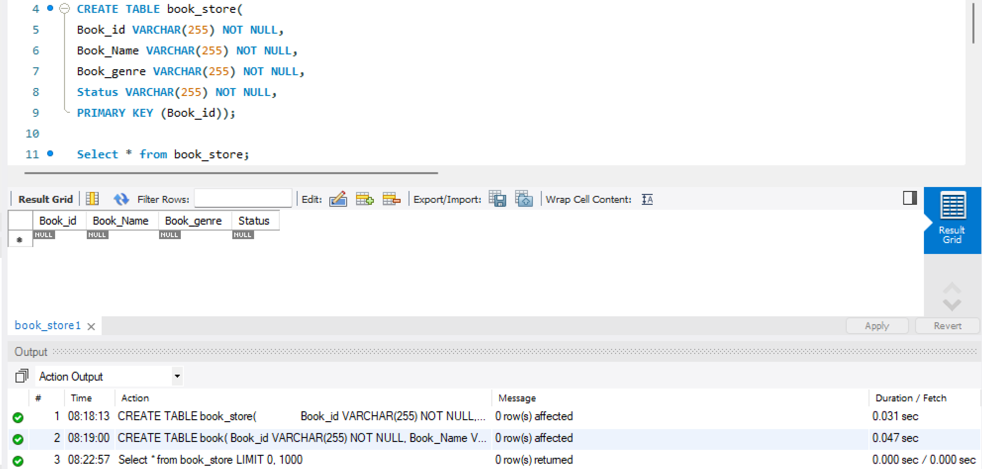

Q2) **Create a table book with columns Book_id VARCHAR(255) NOT NULL, Book_Name VARCHAR(255) NOT NULL, Book_release integer, Book_price integer , Publisher Varchar(10), Book_genre VARCHAR(255) NOT NULL, PRIMARY KEY (Book_id)**

* **Screenshot of MYSQL query & results as shown below:**

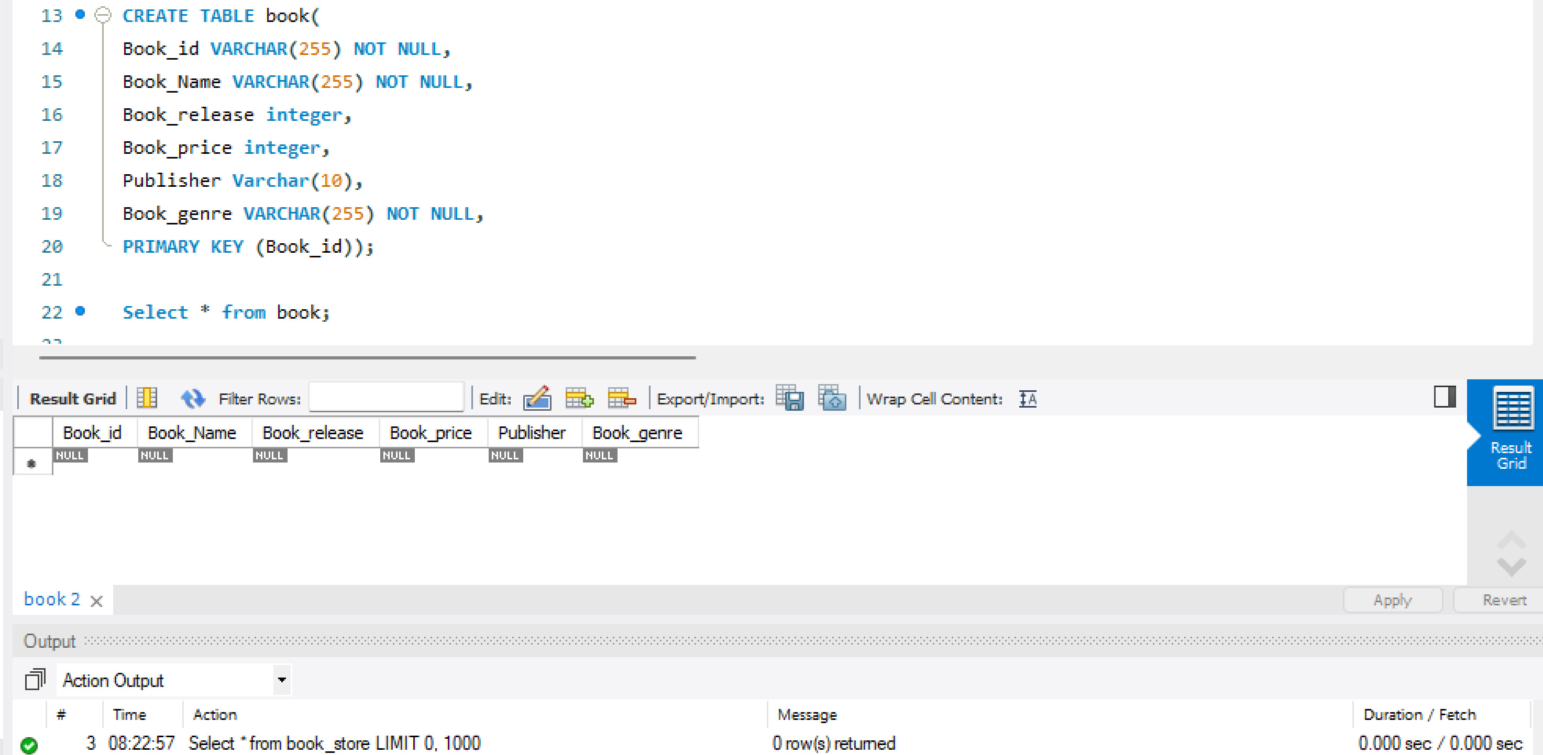

Q3) **Create a table price_logs with columns: id INT(11) NOT NULL AUTO_INCREMENT, Book_id VARCHAR(255) NOT NULL, Old_Book_price DOUBLE NOT NULL, New_Book_price DOUBLE NOT NULL, updated_at TIMESTAMP NOT NULL DEFAULT CURRENT_TIMESTAMP ON UPDATE CURRENT_TIMESTAMP, updated_by varchar(30) NOT NULL, PRIMARY KEY (id), KEY Book (Book_id), CONSTRAINT price_logs_ibfk_1 FOREIGN KEY (Book_id) REFERENCES Book (Book_id) ON DELETE CASCADE ON UPDATE CASCADE**

* **Screenshot of MYSQL query & Results as shown below:**

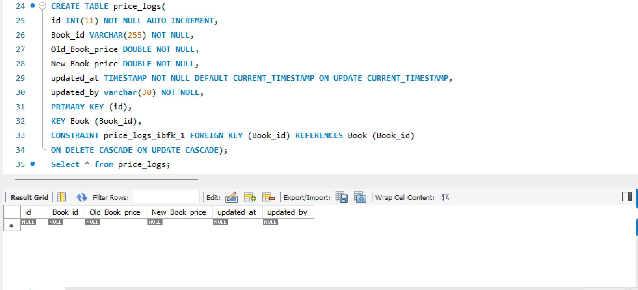

Q4) **Insert Trigger : Create a trigger to insert 7 rows in book_store table every time a new book is inserted in book table.**

* **Screenshot of MYSQL query & results as shown below:**

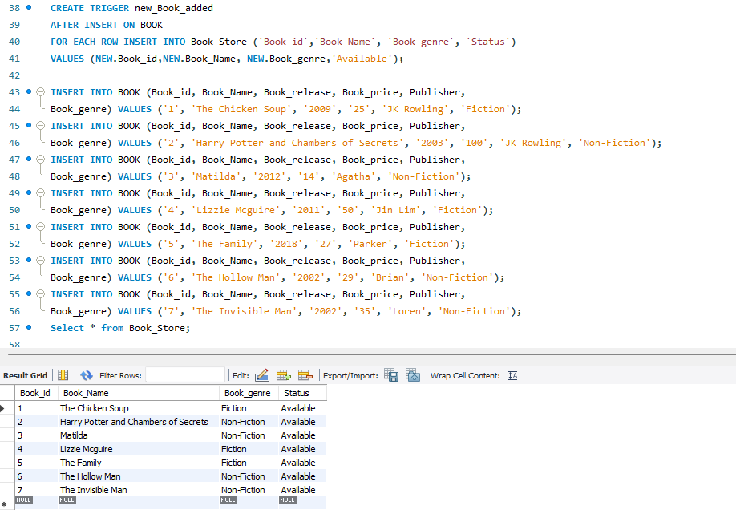

Q5) **Update Trigger: Create a trigger to record/insert the price in price_logs table before updating the book table. Also record the user who updated the price.**

* **Screenshot of MYSQL query & results as shown below:**

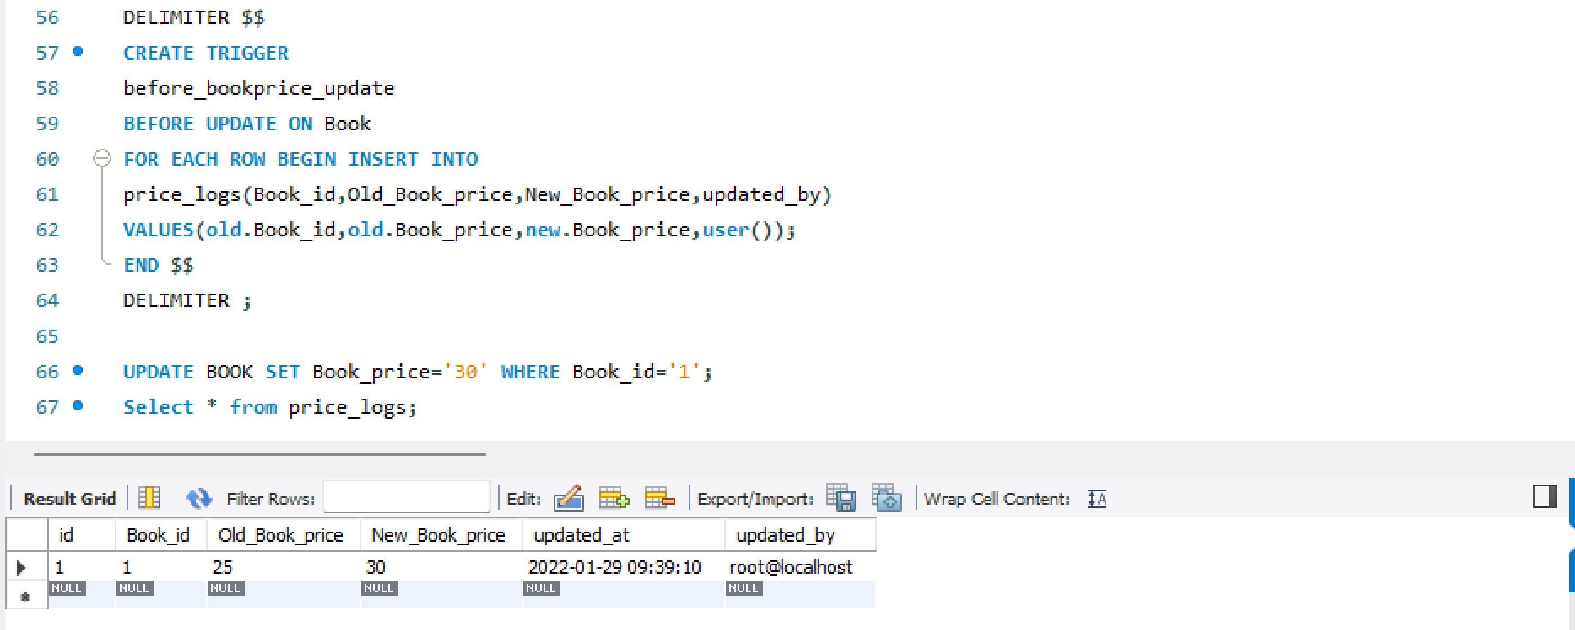

**Q6) Delete Trigger: Create a trigger to delete record from Book_store when a book is deleted.**

* **Screenshot of MYSQL query & results as shown below:**

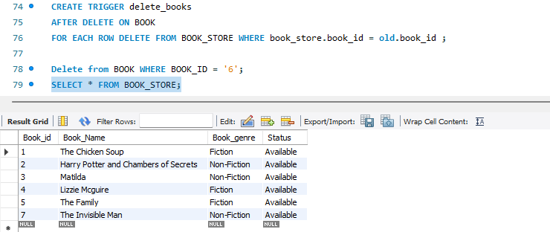

**Q7) Stored Procedure: a. Clarification – We want top3, top5 and all books ranked by their book_id.**

**i. Use book table. Return only top 3 when parameter TOP3 is passed, top 5 when TOP5 is passed else print entire book table.**

* **Screenshot of MYSQL query & results as shown below: CALL GETBOOKS(‘ALL’)**

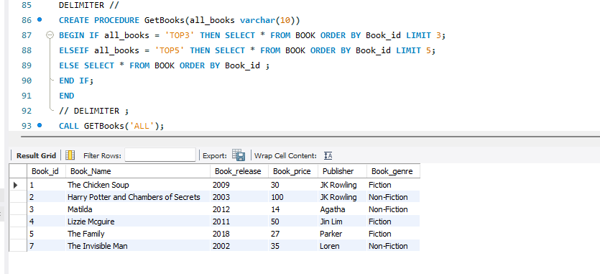

* **Screenshot of MYSQL query & results as shown below: CALL GETBOOKS(‘TOP3’)**

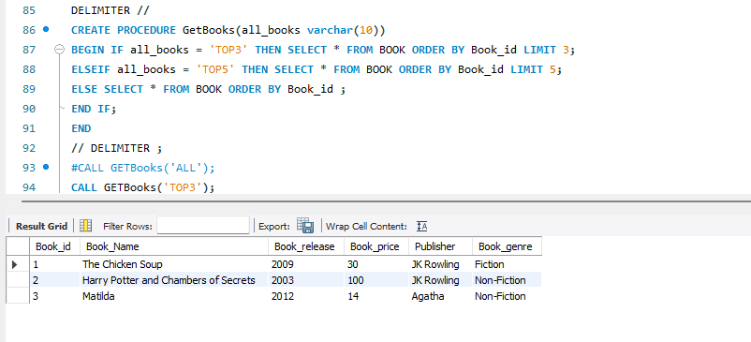

* **Screenshot of MYSQL query & results as shown below: CALL GETBOOKS(‘TOP5’)**

